

Nanotechnology

**CONFERENCE**

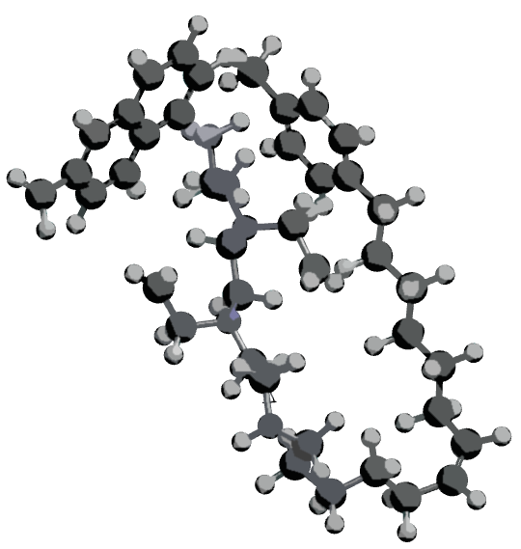

**HARRY BANNINK THEATRE**

**31 JANUARY 2013**

Saxion University

M.H. Tromplaan 28, Enschede

the Netherlands

No Entrance Fee

Catering & Dinner arranged

International

Conference of

**Applied Nanotechnology**

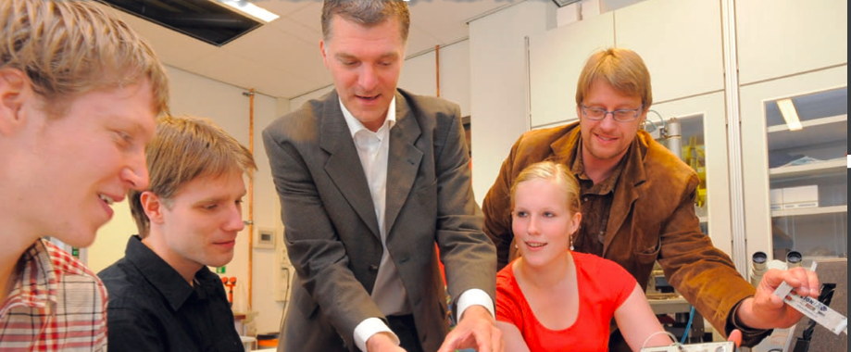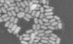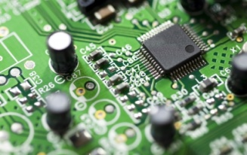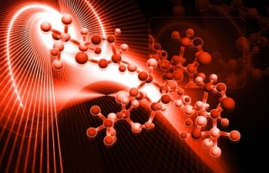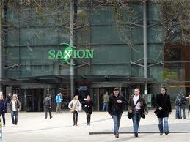

**The opportunity to broaden your international Nanotechnology network**

**Meet: Nanotechnology students and alumni, companies,**

**research institutes and speakers**

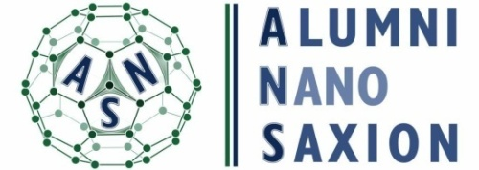





**Programme**

Chairmen: Gregor Luthe / Rene Heideman

*09:00 - 09:30* Doors Open(coffee, tea, cake)

*09:30 - 10:00* Welcome (Ineke van Oldeniel)

*10:00 - 10:45* Jurriaan Huskens, Molecular Nanofabrication, MESA+ Institute of Nanotechnology

*10:45 - 11:30* Jan Eijkel, Lab-on-a-chip group, MESA+ Institute of Nanotechnology

*11:30 - 12:30* Lunch and Poster Sessions

*12:30 - 12:45* Gregor Luthe, Nano Research & Design Center, Saxion University of Applied Sciences

*12:45 - 13:00* Kevin Scholten, Nano Research & Design Center, Saxion University of Applied Sciences

*13:00 - 13:15* Diane te Brake, Wageningen University

*13:15 - 14:00* To be announced

*14:00 - 14:45* Coffee Break and Poster Sessions

*14:45 - 15:30* Medspray XMEMS BV.

*15:30 - 16:15* Chris Roeloffzen Telecommunication Engineering, University of Twente

*16:15 - 17:00* Wilfred van der Wiel, Nanoelectronics, MESA+ Institute of Nanotech

*17:00 - 17:30* Poster Awards (sponsored by Micronit)

*17:30* Dinner at Mr. Hu wok & grill restaurant Institute of Nanotechnologrant

Mr. Hu

All you can eat wok and

grill restaurant

Address:

Gronausestraat 100

Enschede

http://www.dewokmrhu.nl

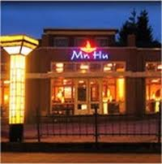

Organizing Committee:

Alumni Nanotechnologie Saxion

alumninanotechnologie.led@saxion.nl

**Imagination is more important than knowledge**

The first edition of the Saxion Nanotech conference, organized by Saxion University and A.N.S. provides a setting to engage future researchers, companies and academics into a broad range of scientific discussions and opportunities for future collaborations.

**Registration**

http://formulieren.saxion.nl/nanotechconference2013

Nanotechnology

**CONFERENCE**