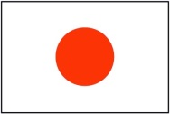

こんにちは(Konnichiwa)! Jó napot kívánok!
In the autumn semester of the academic year 2014/2015 the Foreign Language Lecture offers a new course in English and Japanese.

Fortunately, Tokyo, Japan’s capital was chosen to be host for the 2020 Olympic Games.
Also, Japanese animations (anime) are becoming increasingly famous recognized all over the world.
I think that the number of people who are interested in Japan has been increasing recently.

However, what kind of image do you have of Japan?
I think most of the people answer “Samurai”, “Anime” and “Sushi”. In addition to your images, there is a wonderful and interesting culture, lifestyle and language in Japan.
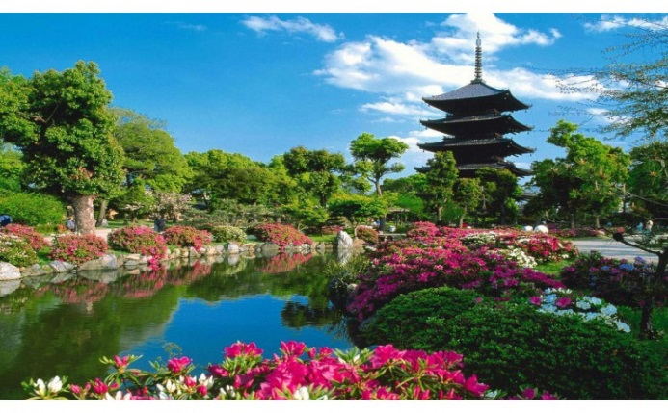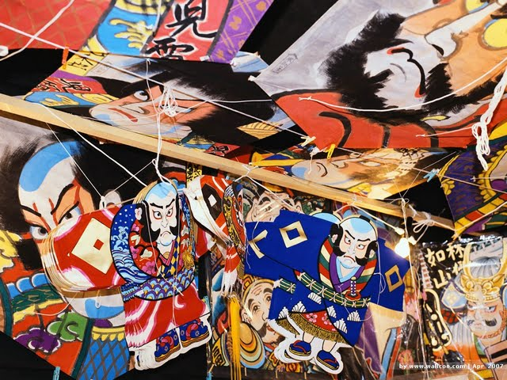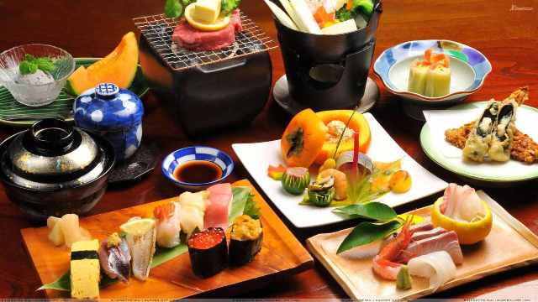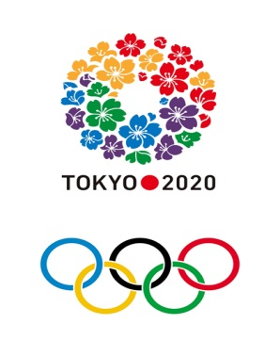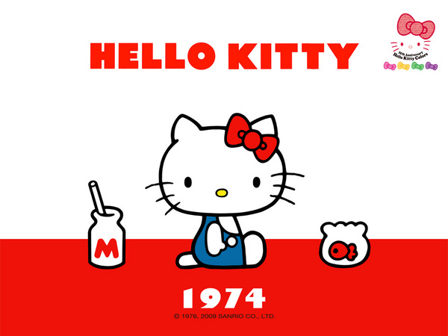

I really would like to tell many people about the attractive aspects of Japan. In my class, I will provide various learning contents from the basic level to the intermediate level. You can learn essential Japanese vocabulary and how to make sentences for a conversation in Japanese.

I hope everyone can enjoy my class. After finishing my classes, you will definitely want to visit this awesome country, Japan! I am looking forward to meeting you in my class♪
Please come to my class!!
Let’s enjoy learning Japanese♪

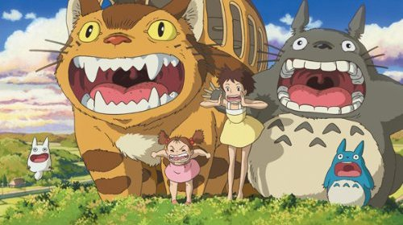

Course Syllabus

Elementary Japanese (Japanese class for beginner)
I would like the students who have never learned Japanese, or who want to learn from beginner level, to take this class.
Students will learn the basic Japanese grammar and writing.
We will start from our easy Beginner basics by learning simple greetings and pronunciations. And then we will study grammar, Japanese alphabets (Hiragana and Katakana) and easy Chinese characters (Kanji). Also I will introduce Japanese traditional culture and subcultures. At the end of the course, students will be able to make a simple conversation. This course will be for those who have never studied Japanese, so the teacher will mainly use English in class.

Intermediate Japanese （Japanese class for advanced student）
This course will be for those who have studied Japanese. Students will be able to learn more Japanese grammar and Kanji (the Chinese characters). At the end of the course, students will be able to speak Japanese more fluently and more naturally. I provide various practical Japanese phrases and dialogues for a conversation. I will also expand on Japanese culture. The teacher will use both English and Japanese in class.

Additionally, to all the students who want to learn and know about Japan, the best way is to take my class; however if you can’t do it, because of your schedule or any other reason, please contact me.
Here is my e-mail address: (gimasakura1222@gmail.com)

