Two colleagues of the University of Pécs Medical School International Studies Center participated in the conference Kleine Sprachen, was nun? (Small languages, what is next?) 20-22 November 2014 organised by Humboldt University in Berlin, where the second volume of the MagyarOK language book due to be published in December was presented.

At the conference lectures were held by international experts on didactic and organizational matters of mediating small languages and cultures, among them Dr. Pelcz Katalin and Szita Szilvia, the author of the language books.

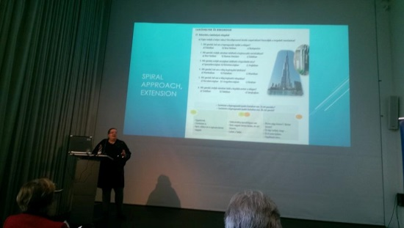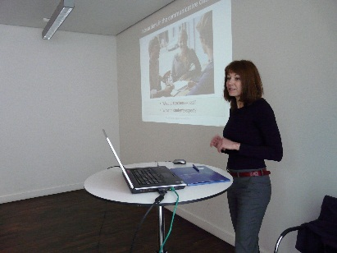
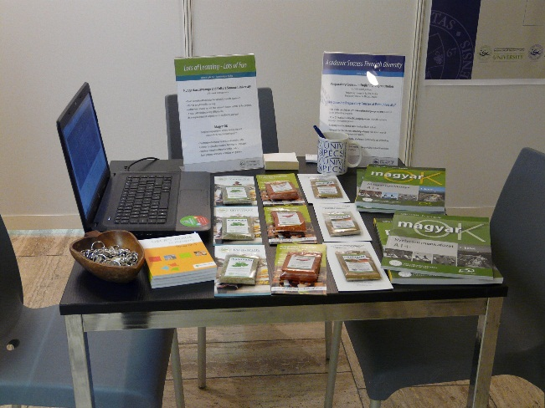
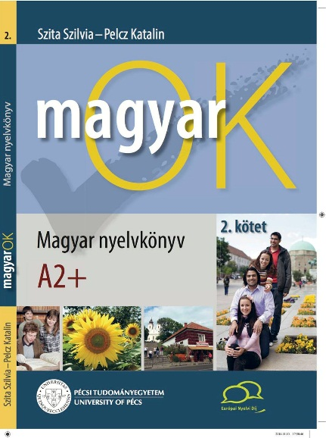

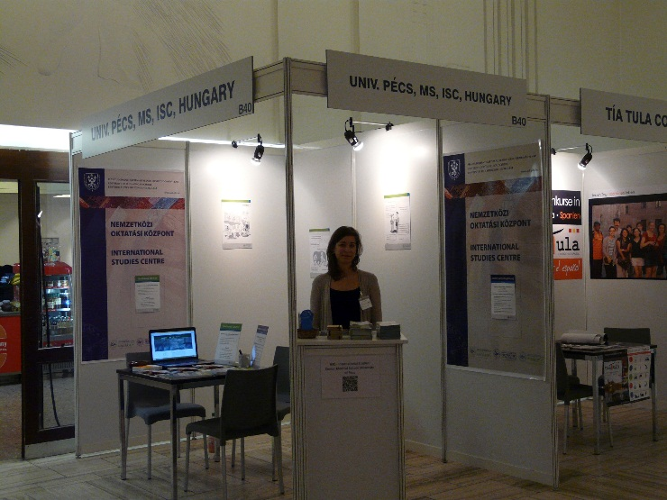

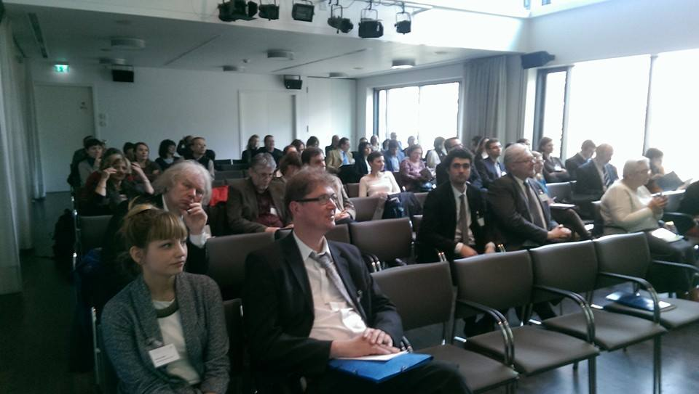
Even then Expolingua Berlin 2014 international exhibition for languages was held where UP MS ISC together with the Foreign Language Center of the University of Pécs were expecting those who wanted to find out more about their offerings. On their stand UP MS ISC was promoting its Hungarian language programme and English language preparatory courses while the Foreign Language Center of UP its ECL language exam on one of the leading international exhibitions of Europe.
As a result of the conference teachers and students of several foreign higher education institutions have become interested in and ordered the second volume of MagyarOK Hungarian as a foreign language study material. By the end of the Expolingua, more than a thousand of promotional material of the University of Pécs and those of the above mentioned programmes have been distributed, and numerous international relationships were established. Cooperation was initiated by Naboomboo seated in Torino that is an innovative multimedia platform with the aim of providing learners with native language teachers, and study materials in Hungarian among several other languages, too.

