Call for papers

IV. EAST-WEST COHESION

INTERNATIONAL SCIENTIFIC CONFERENCE

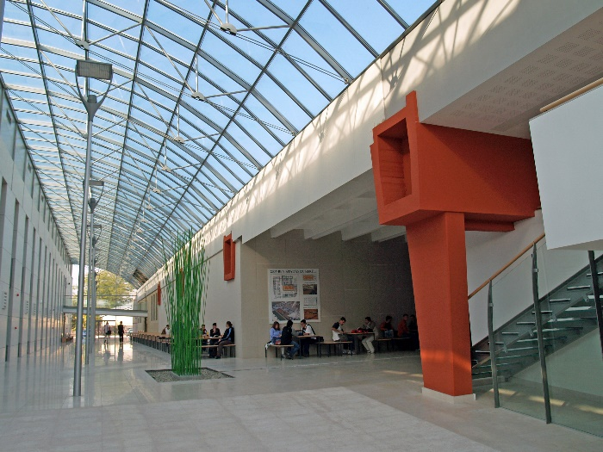
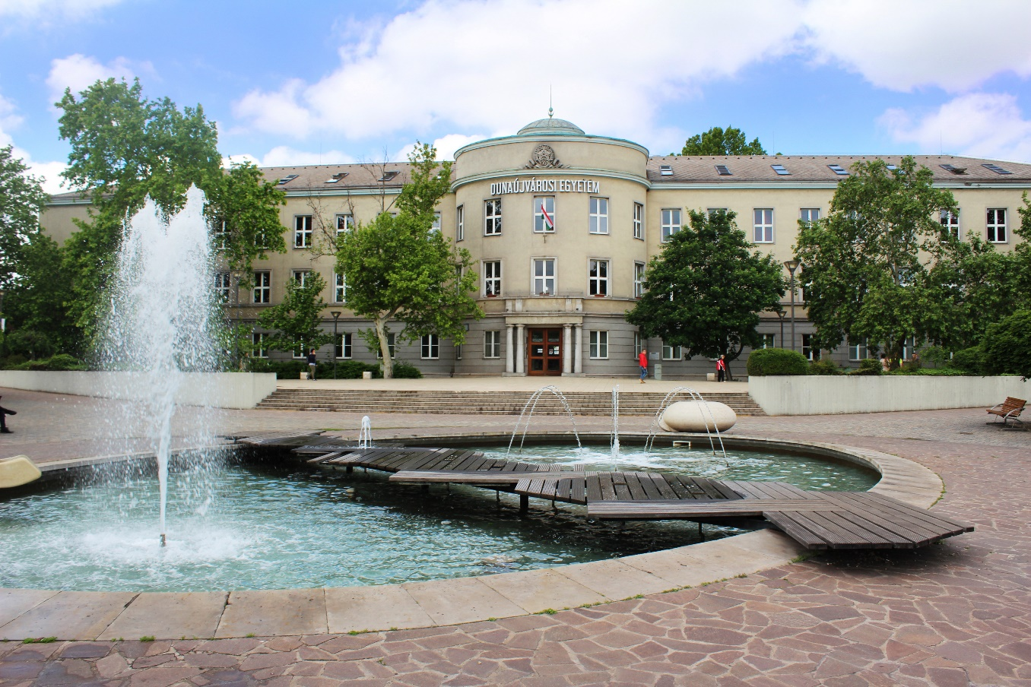
11-12th November 2019. Dunaújváros

1. Aim of the conference

The Opening to the East Strategy which was unfolded in 2014 at the University of Dunaújváros, has contributed to the development and building of international cooperation based on the results of Danube region in East-West relations to strengthen the socio-economic cohesion.

Upon these thoughts, the 4th East-West Cohesion Conference is willing to take a worthy step forward to strengthen the international cooperation between higher educational institutions, spread the modern forms of training, the development of scientific co-operation and to help the effective work of students and doctoral students..

The main topics of the conference: The strengthening of the East-West Cohesion for the development of accessibility and connectivity of energy, transport and social networks.

The duration of the conference is 2 days. During the first day, participants will be able to attend plenary lectures in connection with the main topics. On the first day afternoon and second day the scientific work will continue simultaneously in sections.

Based on the preliminary resolution of the Scientific and Organizational Committee, and in connection with the themes of the conference, we would like to make an Abstract volume and also publish the submitted publications in a Study volume, in accordance with the national standards of publishing. Also there are opportunities to publish in high quality Hungarian professional periodicals.

We expect the participation of the representatives of domestic and international partner institutions, who deal with scientific and educational activities in relation to the defined aims.

2. Organizers of the Conference

Main organizer: University of Dunaújváros (http://www.uniduna.hu)
Co-organizer: Scientific Association for Spatial Development, Esztergom–Budapest (www.sasd.eu)

3. Topics of the conference

- Global challenges in the field of economic, social and educational innovations
- Energy Awareness
- Role of Nuclear Energy in the increase energy efficiency
- Clean Energies
- Technical Innovations
- Safety and Security
- Application of the clean energies
- Development of Transport and Energy Networks
- The state of implementation of the European Danube Regional Strategy (ESDR)
- Strategic issues of adaptation to climate change impacts
- Modern infrastructure developments
- Challenges of the Methods and Competences in the International Management
- New trends and new challenges – innovations in education

4. Important Dates

- 02. September 2019: Opening of online registration
- 10. October 2019: Closing of online registration
- 20. October 2019: Notification of acceptance and sending proforma invoice
- 31. October 2019: Deadline of paying registration fee

- 11-12. November 2019: Date of conference

- 31. December 2019: Submission deadline of full papers
- 31. January 2020: Notification of reviewer’s response
- 31. March 2020: Full paper publication date

Registration fee
 | HUF/person | EUR/person
For Business delegates, for businessmen | 50 000 | 160
For University and college lecturers, researchers * | 35 000 | 110
For PhD candidates ** | 30 000 | 90
* A total of 3 authors can submit a study.
** A total of 2 authors can submit a study.
The registration fee includes:
- the publication published in the Abstract Volume and in the Study Volume
- participation in the plenary session and sections of the conference
- lunch and catering for the two days
- conference banquet on the evening of the first day.
The Scientific Association for Spatial Development issues an invoice for the participation fee.

Conference website:
http://eastwestcohesion.tfte.eu/

András Nagy Dr. Lajos Veres Dr.
Vice Rector of Scientific and Research professor
University of Dunaújváros University of Dunaújváros
Chair Scientific and Organizational Committee

