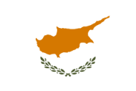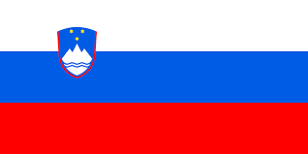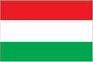

Cyprus, Greece, Poland, Slovenia, Hungary

Horizon Europe Matchmaking event
Culture, Creativity and Inclusive Society

Date: Tuesday, 11th May 2021
Location: Online event
Time: 09h00 CET/10h00 Greek and Cypriot time

European Office of Cyprus in Brussels, NCBR Office in Brussels – Business & Science Poland, Slovenian Business & Research Association, Eötvös Loránd University and National Research, Development and Innovation Office in Hungary would like to invite you to participate in a virtual Cypriot, Greek, Polish, Slovenian, and Hungarian matchmaking event on Cluster 2: Culture, Creativity and Inclusive Society in Horizon Europe.
This virtual matchmaking event will be directed to the research and innovation community from all five countries. The objective of the event is to build a platform for all the partners to share their ideas and find partners for future consortia in Horizon Europe mainly in calls under destination 2: Innovative Research on the European Cultural Heritage and the Culture and Creative Industries.
During the first part of the event the Cluster 2 of Horizon Europe will be presented together with the upcoming Knowledge and Innovation Community of the European Institute of Innovation & Technology focused on the cultural and creative sectors and industries.
The second part is dedicated to the pitch presentations on specific topics within Horizon Europe Cluster 2. Participants are invited to present their interests in certain topics and their project ideas to possible business/research/social partners.
The deadline for registration is May 6th, 2021.

Please register at:
Horizon Europe Matchmaking Event on Cluster 2 (Culture, Creativity and Inclusive Society) on Tuesday, 11 May 2021 at 9:00 am CET
Fill out form

You can register as an attendee (where you will have the opportunity to listen to the pitch presentations) or as a pitch presenter (to make a 3-minute pitch on your ideas and potential). As there is a limited number of pitch presentations places possible, the organizers reserve the right to select the presentations. In case of oversubscription, the organizers keep the right to select the presenters equally (proportionately), one presenter per institution.
This event will provide an opportunity to meet potential partners from Cyprus, Greece, Poland, Slovenia, Hungary and explore opportunities to work together.
Contact: Aliki Varella, e-mail: varella.aliki@ucy.ac.cy
Save the dates and find the right match for your project idea!

