Modul 4: Social and Cultural Diversity in Medical Communication

Introduction

Without taking into account the socio-economic, cultural, ethnic and demographic characteristics of patients, the effectiveness and efficiency of medical activity will be significantly impaired, i.e. the desired outcome, the improvement of health, will not occur or will be difficult to achieve. Doctors cannot change these patient characteristics, but by 'tailoring' their activities and communication to patients, health outcomes can be significantly improved, and health inequalities reduced.
Awareness-raising of patient groups with characteristics that are generally different from those of most doctors is therefore essential in medical education. In addition to awareness-raising, a kind of attitude-shaping is needed to ensure that, by recognising differences, more effective cooperation between doctor and patient can be achieved - through the use of appropriate, i.e. 'culture-competent' communication.
Groups that are disadvantaged in society are also 'handicapped' in healthcare. This can be concrete (e.g. for people with sensory disabilities) or figurative (e.g. for patients with low education, who do not speak a middle-class language and are literate).
The module will cover the following communication situations with disadvantaged groups:
- the poor and poverty as a complex life situation (not only income poverty, but also deprivation of the goods generally accepted in society, a bleak environment, lack of services, etc.)
- belonging to demographic groups that are vulnerable to stereotyping and discrimination (with particular attention to the elderly and women), e.g. young female sex workers
- disadvantaged living situation due to being an ethnic or cultural minority
- sexual minority status, e.g. homosexuals, bisexuals
- disabled groups
- alcoholic patients
- substance abusers, drug-addicts
- obese patients
- elderly patients
- uneducated patients
- patients who are victims of domestic violence

In healthcare, as in business, more and more doctors work and treat patients from other countries and cultures.
Each culture has its own world view and beliefs about health, illness, medicines, treatments, cures, and medical care, which often leads to misunderstandings and difficulties.
Thus, the aim of this module is also to increase medical students' cultural knowledge and awareness of the inter- and socio-cultural influences of health-related beliefs, attitudes, and behaviours, and to develop competencies and skills that will effectively contribute to the care of patients from diverse social and cultural backgrounds in today's multicultural working environment.

Theoretical background

A. Hofstede's culture model

Hofstede (Hofstede et. al., 1990) distinguishes culture as four layers overlapping like onion leaves, as shown in the figure below.

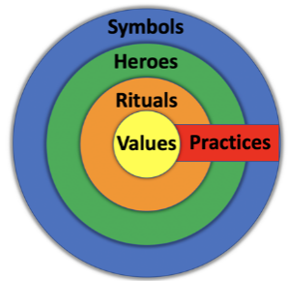
Source: Hofstede et al., 1990:291

Symbols: external, visible things and phenomena, etc.
Heroes: models of behaviour that are highly valued in a given culture and, where appropriate, to be followed
Rites: collective forms of behaviour (e.g. greetings, other customs).
Values: unlike the previous three, values are no longer directly perceptible to external observers. They determine what is perceived as good or bad in a given culture.

B. The development of intercultural sensitivity according to Bennett

According to Bennett's (1986) model, the development of intercultural sensitivity and competence is a phased process, which can be divided into two major units: ethnocentric and ethnorelative phases.
In the first phase, the person concerned views his or her new environment through the lens of his or her own culture. In the next phase, after a period of time that varies from one individual to another, he or she may be able to see and interpret the phenomena of the host culture independently of the perception of his or her own culture. Within the two phases, there are six stages in total, from rejection to integration, in which a person, who has arrived in a culture that may have been completely unknown, can progress.

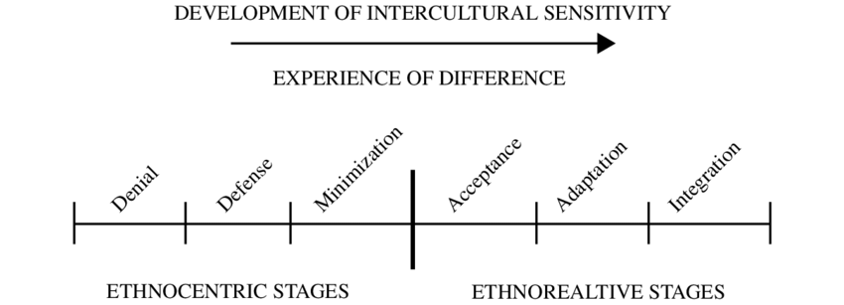

Source: Bennett, 1986:182
C. Deardorff's model of intercultural competence development

Deardorff's (2006) model of intercultural competence development shows the same process from a different perspective. The developmental process leads from initial attitudes through knowledge and understanding and the development of skills through personal interactions to internal and external outputs, i.e. personal development that feeds back into attitudes, making the process a continuous circular development.

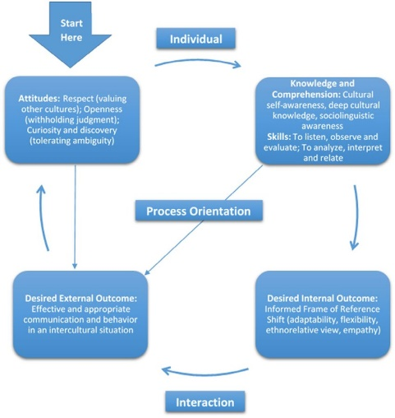

Source: Deardorff 2006:254

D. The need to develop intercultural competence in a healthcare setting

● increasingly complex contexts due to cultural differences, such as
- health and illness,
- cultural differences in symptoms and possible treatments,
- trust in health care,
- minority patients or the multicultural context resulting from migration phenomena can often manifest themselves in situations where
- the patient and the care provider have different cultural backgrounds
- they meet in a third culture
● intercultural competence is increasingly becoming a key competence in an increasingly internationalised labour market
● medical students studying abroad in the context of academic mobility and students in higher medical education in a host culture have a special opportunity to acquire it

Summary

- Preparing medical students to recognise and communicate effectively with different cultural, social, ethnic and demographic groups is particularly important during training.
- It is essential for students to be aware of their existing stereotypes and prejudices, which can affect their communication and medical practice as doctors.
- The personal experience of each case helps recognise and better understand the fact that appropriate communication is not just a moral imperative (a kind of "philanthropic duty"). Good communication is a factor that significantly increases the effectiveness of the doctor's work, especially among patients who are hindered in maintaining and improving their health by a range of limitations (from education to physical access).
- The socio-economic status, education and stigmatisation of certain groups of patients cannot be fundamentally changed by individual doctors.
- However, the way a doctor communicates with a given patient during their encounters, the way they behave in a therapeutic situation, is clearly within their own 'sphere of influence' (i.e. under their own control).
- Better communication, including greater understanding and acceptance, in turn improves cooperation and can lead to more effective treatment, reducing health deterioration and health inequalities for these patients.

References and recommended reading:

Bennett, M. J. (1986). A developmental approach to training for intercultural sensitivity. International journal of intercultural relations, 10(2), 179-196.
Betancourt, J. R. (2006). Cultural competency: Providing quality care to diverse populations. The Consultant Pharmacist, 21(12), pp. 988-995.
Deardorff, D. K. (2006). Identification and Assessment of Intercultural Competence as a Student Outcome of Internationalization. Journal of Studies in International Education, 10(3), 241–266.
Hofstede, G., Neujen, B., Daval Ohayv, D., Sanders, G. (1990). Measuring Organisational Cultures: A Qualitative and Quantitative Study Across Twenty Cases, Administrative Science Quarterly, 35(2), 286-316.
Marek, E., Faubl, N., Németh, T. (2020). Intercultural competence of medical students in Hungary. Intercultural Communication Studies, 29(1).
Rundle, A., Carvalho, M., Robinson, M. (2002). Cultural Competence in Health Care: A Practical Guide 2nd Edition, John Wiley & Sons, Inc., San Francisco

