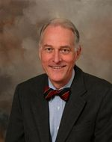

**Michael Gauderer**

**2013. Imre Pilaszanovich**

**Visiting Professor**

Michael Gauderer is well known internationally among pediatric surgeons. He is a Professor of Pediatric Surgery at the Greenville System Children Hospital, University of South Carolina, USA. He was born in Rudolfstadt / Thüringen, Germany and began his medical studies at the Federal University of Rio de Janeiro, Brazil and graduated in 1968. After completing his general surgical training at The Graduate Hospital of the University of Pennsylvania, he began his fellowship in Pediatric Surgery at The Children's Hospital of Philadelphia in 1976. The first 16 years of his career he spent at the Rainbow Babies and Children Hospital in Cleveland, Ohio. He relocated to Greenville Hospital in 1995.

Dr Gauderer is a pioneer in [minimally invasive surgery](http://www.ghssurgery.org/minimally-invasive-surgery.php) techniques. Nearly 25 years ago, he conceived and developed the percutaneous endoscopic gastrostomy (PEG) procedure that is now the standard for gastric access worldwide.

Although his clinical experience encamps all spectrum of Pediatric Surgery, Dr Gauderer area of interest are neonatal surgery, stomas of intestinal tracts and chest wall deformities.

Professor Gauderer is a fellow of American College of Surgeons and American Academy of Pediatrics and a member of numerous National and Internationals Medical Societies. He is a member of the editorial board of Journal of Pediatric Surgery and participates in peer review process for several Medical Publications.

Professor Gauderer has published extensively and is the author of over 150 papers and 40 books and chapters. His lifelong commitment to teaching, continues by actively contributing to Surgery in Pediatrics and development of new surgical techniques and devices.

Dr Gauderer and his wife Barbara have three children, Andrea, Christian and Martina and live in Salem, South Carolina.

It is a great privilege and pleasure to welcome this most distinguished and accomplished colleague to Pecs as 2013 Imre Pilaszanovich visiting professor.

**IMRE PILASZANOVICH**

**VISITING PROFESSORSHIP**

**7th OCTOBER 2013 (Monday)**

**16.00**

**VENUE: MAIN BUILDING / MEDICAL FACULTY**

**ORGANIZED BY**

**THE DEPARTMENT OF PAEDIATRICS**

**MEDICAL FACULTY**

**PÉCS UNIVERSITY**

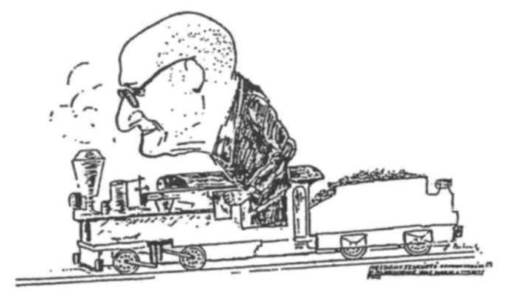

|  |
| --- |
| **THE IMRE PILASZANOVICH VISITING PROFESSORSHIP IS A TEACHING ACTIVITY AT THE SURGICAL UNIT OF THE DEPARTMENT OF PAEDIATRICS**  **OF THE MEDICAL FACULTY OF PÉCS UNIVERSITY,**  **PÉCS, HUNGARY** |

**The 23nd Imre Pilaszanovich Lecture - 2013**

**WELCOME**

**Dénes Molnár**

Professor of Paediatrics

**András Pinter**

Professor Emeritus of Paediatric Surgery

**Gastrostomies: evolution, techniques, indications and complications**

# Michael GAUDERER

# Greenville System Children Hospital / University of South Carolina Greenville / USA

**IMRE PILASZANOVICH VISITING PROFESSORS**

1. Hardy W. Hendren Boston, USA
2. Arnold G. Coran Ann Arbor, USA
3. Hugo Sauer Graz, Austria
4. R. Lawrence Kroovand Winston-Salem, USA
5. Sidney Cywes Cape Town, S. Africa
6. Urs Staufer Zürich, Switzerland
7. Takeshi Miyano Tokyo, Japan
8. Daniel G. Young Glasgow, UK
9. Jay L. Grosfeld Indianapolis, USA
10. Alberto Pena New York, USA
11. Prem Puri Dublin, Ireland
12. Lewis Spitz London, UK
13. Alexander Holschneider Cologne, Germany
14. John M. Hutson Melbourne, Australia
15. Juan A. Tovar Madrid, Spain
16. Michael E. Höllwarth Graz, Austria
17. Devendra K. Gupta New Delhi, India
18. Richard G. Azizkhan Cincinnati, USA
19. Donald Nuss Norfolk, USA
20. Alastair Millar Cape Town, South Africa

2011. Benno M. Ure Hannover, Germany

2012. Jean-Michel GUYS Marseilles, France

**2013. Michael Gauderer Greenville, USA**

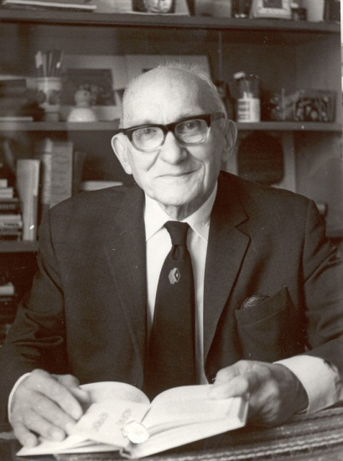

**IMRE PILASZANOVICH**

**(1911-1990)**

IMRE PILASZANOVICH’s name and activities are well known in many European countries. In Pécs, he has become a legend. „Uncle Pila” as everybody called him, not only treated thousands of sick children, but also contributed greatly to the development of paediatric surgery in Hungary.

Dr. Imre Pilaszanovich was born on May 4th, 1911. He graduated from the Medical School of Innsbruck, Austria. He was a resident and later senior resident in surgery at the General Hospital in Zagreb, Croatia, from 1935 to 1941. He continued his work at the Surgical Department of the Medical University of Pécs, Hungary ‘till 1947. At that time, paediatric surgery was not an independent specialty. As a general surgeon, he regularly attended and treated the surgical patients of the Department of Paediatrics, where he worked as the head of the Paediatric Surgical Unit until retirement in 1981.

A large number of young paediatric surgeons were trained by him. He was very active in many fields of paediatric surgery, such as anorectal agenesis, neonatal surgery as well as tuberculosis of bones and joints and acute osteomyelitis.

Dr. Pilaszanovich had over 80 publications. He was the president of Paediatric Surgical Section of the Hungarian Association of Surgeons between 1976 and 1979. He received several awards, honours and honorary memberships which all reflect his successful career. He was a close friend of Professor Fritz Rehbein of Bremen, Germany.

He continues to live in the mind of his students, friends and patients. By establishing the “*Imre Pilaszanovich Visiting Professorship*” his colleagues and friends wish to cherish the memory of this outstanding man.